From: https://brownstone.org/articles/governments-national-security-arm-led-the-covid-response/

Government’s National Security Arm Took Charge During the Covid Response
BY Debbie LermanDEBBIE LERMAN NOVEMBER 3, 2022 GOVERNMENT, POLICY, PUBLIC HEALTH 11 MINUTE READ

In previous articles I discussed the probability that Deborah Birx, the White House Coronoavirus Task Force Coordinator, was not a representative of the public health agencies but, rather, was appointed by the National Security Council. I now have proof that this was, indeed, the case. I have also uncovered documents that show:
- As of March 13, 2020 the National Security Council (NSC) was officially in charge of the US government’s Covid policy.
- Starting on March 18, 2020, The Federal Emergency Management Agency (FEMA), under the Department of Homeland Security (DHS), was officially in charge of the US government’s Covid response.

The Covid Task Force Coordinator was brought in by the NSC
On March 11, 2020, at a Heritage Foundation Talk, Trump’s National Security Advisor, Robert O’Brien, when discussing what the White House and NSC were doing about the virus, said:
“We brought into the White House Debi Birx, a fantastic physician and ambassador from the State Department. We appreciate Secretary Pompeo immediately moving her over to the White House at our, well at the President’s, request.” (min. 21:43 – 21:56)

The National Security Council was in charge of our Covid Policy
An astonishing government document dated March 13, 2020 entitled: “PanCAP Adapted U.S. Government COVID-19 Response Plan” (PanCAP-A) (embedded at the end of this piece) reveals that United States policy in response to SARS-CoV-2 was set not by the public health agencies designated in pandemic preparedness protocols (Pandemic and All Hazards Preparedness Act, PPD-44, BIA), but rather by the National Security Council, or NSC.
This is the pandemic response org chart, from p. 9 of PanCAP-A, showing the NSC solely responsible for Covid policy:
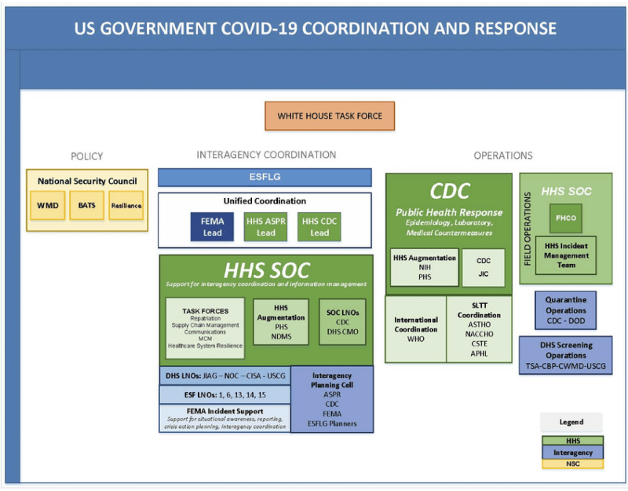

What is the National Security Council?
According to its website, the NSC “is the President’s principal forum for considering national security and foreign policy matters with his or her senior advisors and cabinet officials.”
The NSC does not include as regular attendees any representatives from public health-related agencies.
It does include the President’s National Security Advisor, who is “the President’s most important source of policy advice on foreign and national security policy,” according to the White House Transition Project’s document for The National Security Advisor and Staff. “In some administrations,” the document continues, “foreign and national security policy making is essentially centralized in the hands of the NSC advisor with minimal input from cabinet-level departments such as State or Defense.” Furthermore, “there is little statutory or legal constraint (beyond budgetary limits) in how the role of NSC advisor is defined or how the NSC staff is organized and operates.” (pp. 1-2)
In other words, if the NSC is in charge of Covid response, it can pretty much decide and impose anything it wants without any constraints or oversight, as long as the President agrees, or at least lets them take the lead.
But what exactly is PanCAP-A, in which the NSC appears in such a surprising Covid-response leadership role?

PanCAP-A is the closest we have to a national Covid response plan
PanCAP-A stands for Pandemic Crisis Action Plan – Adapted.
An exhaustive online search did not turn up the Pandemic Crisis Action Plan from 2018, which was apparently “adapted” to produce PanCAP-A. However, the existence of the original document is confirmed in various documents, including a statement on “Preparedness for COVID-19” presented to the US Senate Committee on Homeland Security and Government Affairs on April 14, 2021.
In this statement, Elizabeth Zimmerman, a former FEMA Administrator, who is sharing with the Senate Committee her findings on “The Initial Pandemic Response and Lessons Learned,” says she had trouble finding the government’s plan for the US response to Covid-19:
“In researching disaster response plans to refresh my memory for this hearing, I found several detailed plans that were publicly available and saw mention of plans and directives that were not publicly available. The time spent searching for these plans and directives was frustrating for an experienced emergency manager…”
Then, in reference to the plans she was able to find, or knew about but may not have actually seen, she says:
“Following the Anthrax attacks in 2001, the federal government invested a lot of money on processes and plans centered on public health response – bioterrorism and pandemics in particular. … One of the latest plans, January 2017, is the Biological Incident Annex (BIA) to the Response and Recovery Federal Interagency Operational Plans (FIOPs). The BIA is the federal organizing framework for responding and recovering from a range of biological threats, including pandemics.
However, it was not publicly seen that these plans were being used during the onset of COVID-19 nor does it seem that there was a national COVID-19 response plan.
Finally, she references the 2018 PanCAP, the adapted PanCAP, and then makes another surprising statement:
Also, there was a 2018 Pandemic Crisis Action Plan (PanCAP) that was customized for COVID-19 specifically and adopted in March 2020 by HHS and FEMA; the plan identified the U.S. Department of Health and Human Services (HHS) as the Lead Federal Agency (LFA) with FEMA supporting for coordination. However, a mere five days after the national COVID-19 emergency was announced, FEMA became the LFA.” [BOLDFACE ADDED]

FEMA replaced HHS as the Lead Federal Agency, with no warning or preparation
What Zimmerman is saying here is that, in the PanCAP-A org chart, where the NSC is in charge of policy and the HHS is in charge of almost everything else – actually, FEMA is in charge of everything else.
This means that, in effect, starting on March 18, 2020, the HHS –which comprises the CDC, NIAID, NIH and other public-health-related agencies – had NO OFFICIAL LEADERSHIP ROLE in pandemic response – not in determining policy and not in implementing policy.
This is a staggering piece of information, considering that all pandemic preparedness plans, as Zimmerman notes, placed the Health and Human Services Agency (HHS) at the helm of pandemic response.

How was FEMA put in charge?
[End of text extracted for this file. –FNC]

November 3, 2022 is the date of the Brownstone document.in line 1.
20200320 is the first part of the filename of this short document you are reading.

